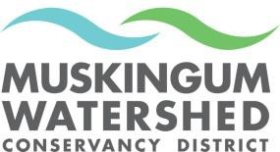Muskingum Watershed Conservancy District Engineering Group
Annex Building- 2050 Reiser Ave SE
New Philadelphia, OH 44663
(330) 343-6647 Toll-free (877) 363-8500
Please include my company in the Contractor Database:

Company

Mailing Address

Primary Contact

Phone _Fax Cell

Email Web Page

Check all that apply:

€  €  € | Asphalt/ Sealant Bridge  Building Construction | €  €  €  € | Excavation Fence Flooring General | €  €  € | Pump Out Services Roofing  Sewer Cleaning/
€ | Building |  | Contracting |  | Camera
 | Renovation | € | HVAC | € | Site Prep
€  € | Carpentry Concrete | € | Hauling, Transport | € | Shoreline Stabilization
€ | Dam | € | Landscaping | € | Tree Clearing
€ | Docks | € | Masonry | € | Water
€ | Doors, Windows | € | Painting | € | Wastewater
€ | Dredge | € | Plumbing | € | Other, please list:
€ | Drilling | € | Retaining Walls
€ | Electrical | € | Road Construction

We are interested in work in these areas:

€  € | Atwood/ Leesville Charles Mill/ Pleasant Hill | €  € | Mohawk/ Wills Creek  Tappan | € | Chippewa Subdistrict
€ | Clendening/ Piedmont | € | Seneca

Please submit the information to the MWCD Engineering via mail/email to: 2050 Reiser Ave SE New Philadelphia, Ohio 44663
Email: davidl@mwcd.org

